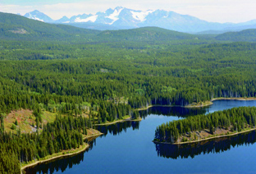
Stand Development Monitoring
Kamloops TSA Summary

This is a working draft OF DATA SUMMARIES FROM a Stand Development Monitoring SURVEY. THE data presented are preliminary.

These summaries are from polygons surveyed in the Kamloops TSA in 2012. The summaries demonstrate the range and scope of information that can be expected from SDM data.

Currently, field survey data is entered into an EXCEL spreadsheet template. This template provides a polygon data summary for immediate use. The spreadsheets are then loaded into the SDM ACCESS data base. This database can then be queried to produce an aggregated data summary like this one that includes data from multiple polygons within a TSA. The queries can be adjusted to extract data in various combinations depending on the user’s needs.

This summary is not an analysis; it provides limited interpretation of the data. Reports examining specific questions regarding productivity or that seek to explain trends and other behaviours can be constructed based on this data along with the use of other supporting tools or evidence.

Provincial and regional forest health and Silviculture staff can be asked to help with the interpretation of the information presented in the summaries and in the creation of more detailed reports.

Your input as comments and suggestions are needed to further develop these summaries. Please contact Harry.Kope@gov.bc.ca and provide your suggestions for improvement.
STAND DEVELOPMENT MONITORING - Kamloops TSA Summary
Purpose and Audience – Data summaries can help statutory decision makers and operational foresters make informed decisions on stand development, TSR data package inputs, FSP renewals, and FFT activity priorities. They provide information on the growth and health of managed stands.
The Forest and Range Evaluation Program in conjunction with the provincial forest health program have designed an evaluation protocol (Stand Development Monitoring - SDM) that assesses the condition of post-free-growing managed stands by measuring stand attributes and the impact of biotic and abiotic damaging factors on stand health to determine whether these free-growing stands are meeting productivity expectations.
NOTE – This report provides summary information obtained from the surveyed polygons. Inferences from these summaries should be made cautiously.
This summary includes data on: Sample Summary Forest Health Stand Density Species Composition Site Index
SAMPLE SUMMARY
Polygon and polygon population attributes, and numbers and percentages of sampled live trees.

A1 – number of polygons sampled
Survey year: | 2010 | 2011 | 2012
DHW | 7 | 17 | 3
DKA | 11 | 12 | 6

A3 - sampled polygon attributes
Attribute | nª | Mean | SD^{b} | Range
Polygon net area (ha) | 35 | 20.1 | 13.3 | 6 to 59
Stand Age (yrs) | 10 | 22.8 | 4.6 | 16 to 32
Harvest to Declaration (yrs) | 10 | 11.8 | 3.5 | 6 to 18
Planting to Declaration (yrs) | 17 | 10.8 | 5.1 | 3 to 23
Declaration to SDM (yrs) | 17 | 9.9 | 4.0 | 1 to 15
ª. Differing ‘n’ values indicate missing information for some polygons.
^{b}. SD - Standard Deviation

A4 - sample population coverage
TSA  polygon population  (n) | Total polygon population  area (ha) | Number Polygons  ≥5 ha  (n) | Population polygon area  ≥5 ha  (ha) | Number of polygons sampled  (n) | Sampling intensity by number of polygons | Area  sampled  (≥5 ha)  (ha) | Sampling intensity by area
1890 | 31311 | 1353 | 30089 | 35 | 2.6% | 704.1 | 2.3%

A5 - number and percentage of sampled total live trees
Tree species: | Act | Bl | Cwi | Ep | Fdi | Hwi | Pli | Pw | Sx | Total
Number | 422 | 1094 | 1209 | 855 | 987 | 372 | 3182 | 81 | 983 | 9185
Percent | 5 | 12 | 13 | 9 | 11 | 4 | 35 | 1 | 11 | 100
X1 - Tree Species Abbreviations
Act - Poplar Hwi – Western Hemlock (interior)
Bl – Subalpine Fir Pli - Lodge Pole Pine (interior)
Cwci– Western Red Cedar (interior) Pw – White Pine
Ep – Common Paper Birch Sx – Spruce hybrid
Fdi – Douglas-fir (interior)

FOREST HEALTH
Forest Health is assessed using the SDM damage criteria for mid-rotation stands (see Appendix 1). The damage criteria establish forest health threshold tolerances identifying unacceptable and damaged trees, which are labelled pest affected trees. In the Kamloops TSA the pathogen most recorded was Western Gall Rust (DSG); the insect was Mountain Pine Beetle (IBM); The animal damage was Moose (AM); the abiotic damage was Snow Press (NY).
B1 – average stems per ha by forest health status
X2 – tree layers
Layer 1 >12.5 cm dbh
Layer 2 7.5 to 12.5 cm dbh
Layer 3 >1.3 m in height to 7.49 cm dbh
District | Live Acceptable Trees (sph) | Live Unacceptable Trees (sph) | Dead Unacceptable Trees (sph) | Total Stemsª (sph)
Headwaters  Kamloops  Total | 2960  3810  3453 | 201  235  221 | 238  151  188 | 3399  4197  3862  X3 – forest health abbreviations  DSG – Western gall rust IDB – Two-year budwormm AH - Hare  DRA – Armillaria root disease ISQ – Sequioa pitch moth AZ - Beaver  DSB – White Pine blister rust IWW – Warren’s root collar weevil AD - Deer  DSA – Atropelis canker IBI – Engraver beetle NY – Snow press  DFS – Dothistroma needle blight AM – Moose VT – Vegetation competition  DLD –Dermea canker AS – Squirrel NF - Flooding  IBM – Mountain Pine beetle IBI – Engraver beetles NGK – Frost Kill  IWS –White Pine weevil AB - Bear TL – Logging TM – Mechanical damage  IAG –Cooley Spruce gall adelgid AP – Porcupine NS – Slide U - Unknown
ª For forest health purposes total stems equals all live trees plus all dead trees.
B2 - forest health factors detected
(Brackets are the number of plots with a specific forest health factor. Plots =500)
Pathogen DSG (86) DRA (61) DSB (27) DSA (7) DFS (2) DLD (1)
Insect IBM (27) IWS (18) IAG (5) IDB (4) IWW (4) ISQ (3) IBI (1)
Animal AM (11) AS (8) AH (6) AB (5) AP (5) AZ (3) AD (2)
Abiotic NY (91) VT (70) NF (6) NGK (5) TL (3) TM (2) NS (1)
Unknown U (62)

B3 - incidence of forest health factor by bec
BEC | Tree Layer | Total Stems | Acceptable Trees |  |  | Unacceptable Trees |  |  |  |  |  | Percent incidence^{c} of Forest Health Factor^{d} for each tree layer
 |  |  |  |  |  | Live |  |  | Dead
BEC | Tree Layer | Total Stems | n | (%^{b}) | n |  | (%^{b}) | n |  | (%^{b}) | DSG |  | DRA | DSB | DSA | IMB | IWS | AM | AS | AH | NY | VT | NF | Other | U
ESSFdc3 | 1 | 3 | 3 |  | 0 |  |  | 0 |  |  | - |  | - | - | - | - | - | - | - | - | - | - | - | - | -
 | 2 | 30 | 30 |  | 0 |  |  | 0 |  |  | - |  | - | - | - | - | - | - | - | - | - | - | - | - | -
 | 3 | 36 | 34 |  | 1 |  |  | 1 |  |  | - |  | - | - | - | - | - | 2.8 | - | - | - | - | - | - | -
 |  | 69 | 67 | (97.1) | 1 |  | (1.5) | 1 |  | (1.4) | 0.0 |  | 0.0 | 0.0 | 0.0 | 0.0 | 0.0 | 1.4 | 0.0 | 0.0 | 0.0 | 0.0 | 0.0 | 0.0 | 0.0
ESSFwc2 | 1 | 21 | 18 |  | 3 |  |  | 0 |  |  | - |  | - | - | - | - | 9.5 | 4.8 | - | - | - | - | - | - | -
 | 2 | 126 | 110 |  | 16 |  |  | 0 |  |  | - |  | - | - | - | - | 3.2 | 6.3 | - | 3.2 | - | - | - | - | -
 | 3 | 375 | 336 |  | 39 |  |  | 0 |  |  | - |  | 0.5 | - | - | - | 2.4 | 1.3 | - | 5.1 | 0.3 | - | - | 0.8 | -
 |  | 522 | 464 | (88.9) | 58 |  | (12.5) | 0 |  | (0.0) | 0.0 |  | 0.4 | 0.0 | 0.0 | 0.0 | 2.9 | 2.7 | 0.0 | 4.4 | 0.2 | 0.0 | 0.0 | 0.6 | 0.0
ESSFxc | 1 | 9 | 7 |  | 1 |  |  | 1 |  |  | - |  | - | - | - | - | - | - | - | - | - | 11.1 | - | 11.1 | -
 | 2 | 33 | 31 |  | 2 |  |  | 0 |  |  | - |  | - | - | - | - | - | - | - | 3.0 | - | 3.0- | - | - | -
 | 3 | 64 | 59 |  | 4 |  |  | 1 |  |  | - |  | - | - | - | - | - | - | - | 3.1 | - | 1.6 | - | 3.1 | -
 |  | 106 | 97 | (91.5) | 7 |  | (7.2) | 2 |  | 1.9 | 0.0 |  | 0.0 | 0.0 | 0.0 | 0.0 | 0.0 | 0.0 | 0.0 | 2.8 | 0.0 | 2.8 | 0.0 | 2.8 | 0.0
ICHmw2 | 1 | 18 | 16 |  | 2 |  |  | 0 |  |  | - |  | - | - | - | - | - | - | - | 5.6 | - | - | - | 5.6 | -
 | 2 | 41 | 33 |  | 6 |  |  | 2 |  |  | - |  | 7.3 | - | - | - | - | - | - | 4.9 | - | - | - | 7.3 | -
 | 3 | 163 | 128 |  | 24 |  |  | 11 |  |  | - |  | 3.7 | - | - | - | - | - | - | 13.5 | 4.3 | - | - | - | -
 |  | 222 | 177 | (79.7) | 32 |  | (18.1) | 13 |  | (5.9) | 0.0 |  | 4.1 | 0.0 | 0.0 | 0.0 | 0.0 | 0.0 | 0.0 | 11.3 | 3.2 | 0.0 | 0.0 | 1.8 | 0.0
ICHmw3 | 1 | 195 | 162 |  | 18 |  |  | 15 |  |  | 1.5 |  | 2.1 | 2.1 | 1.0 | 3.1 | 1.0 | - | - | 1.0 | - | 0.5 | - | 4.6 | -
 | 2 | 368 | 318 |  | 23 |  |  | 27 |  |  | 1.1 |  | 1.1 | 2.4 | 0.8 | 1.4 | 1.4 | - | - | 1.1 | 0.3 | - | 0.8 | 3.3 | -
 | 3 | 1906 | 1670 |  | 94 |  |  | 142 |  |  | 0.7 |  | 2.8 | 1.9 | 0.1 | - | 0.2 | - | 0.2 | 1.8 | 2.9 | 0.1 | 0.9 | 0.6 | 0.1
 |  | 2469 | 2150 | (87.1) | 135 |  | (6.3) | 184 |  | (7.5) | 0.8 |  | 2.5 | 2.0 | 0.2 | 0.4 | 0.4 | 0.0 | 0.2 | 1.7 | 2.3 | 0.1 | 0.9 | 1.3 | 0.0
a. Averages on a per ha basis b. For forest health purposes total stems equals total live plus total dead c. Percent of the total stems d. Only the top 13 forest health factors are included in the table

FOREST HEALTH (continued)
B3 - incidence of forest health factor by bec
BEC | Tree Layer | Total Stems | Acceptable Trees |  |  | Unacceptable Trees |  |  |  |  |  | Percent incidence^{c} of Forest Health Factor^{d} for each tree layer
 |  |  |  |  |  | Live |  |  | Dead
BEC | Tree Layer | Total Stems | n | (%^{b}) | n |  | (%^{b}) | n |  | (%^{b}) | DSG |  | DRA | DSB | DSA | IMB | IWS | AM | AS | AH | NY | VT | NF | Other | U
ICHwk1 | 1 | 50 | 46 |  | 4 |  |  | 0 |  |  | 4.0 |  | - | - | 2.0 | - | - | - | - | 2.0 | - | - | - | - | -
 | 2 | 41 | 39 |  | 2 |  |  | 0 |  |  | - |  | - | - | - | - | - | - | - | 4.9 | - | - | - | - | -
 | 3 | 166 | 159 | 7 |  |  | 0 |  |  | 0 |  |  | - | - | - | - | - | - | - | 3.6 | - | - | - | - | 0.6
 |  | 257 | 244 | (94.9) | 13 |  | (5.3) | 0 |  | (0.0) | 0.8 |  | - | - | 0.4 | - | - | - | - | 3.5 | - | - | - | - | 0.4
IDFdk1 | 1 | 15 | 7 |  |  |  |  | 8 |  |  | - |  | - | - | - | 53.3 | - | - | - | - | - | - | - | - | -
 | 2 | 65 | 53 |  | 2 |  |  | 10 |  |  | 3.1 |  | - | - | - | 15.4 | - | - | - | - | - | - | - | - | -
 | 3 | 353 | 340 |  | 3 |  |  | 10 |  |  | 0.6 |  | 0.6 | - | - | 0.6 | - | - | - | - | - | - | - | - | 2.0
 |  | 433 | 400 | (92.4) | 5 |  | (1.3) | 28 |  | (6.5) | 0.9 |  | 0.5 | 0.0 | 0.0 | 4.6 | 0.0 | 0.0 | 0.0 | 0.0 | 0.0 | 0.0 | 0.0 | 0.0 | 1.6
IDFmw2 | 1 | 80 | 75 |  | 4 |  |  | 1 |  |  | 2.5 |  | - | - | - | 1.3 | - | - | - | - | - | - | - | 2.5 | -
 | 2 | 183 | 162 |  | 13 |  |  | 8 |  |  | 2.2 |  | 3.8 | - | - | 0.5 | - | - | 0.5 | 1.1 | 0.5 | 0.5 | - | 2.2 | -
 | 3 | 669 | 575 |  | 19 |  |  | 75 |  |  | 0.7 |  | 3.4 | - | - | 0.3 | - | - | - | 22 | 6.7 | - | - | 0.6 | -
 |  | 932 | 812 | (87.1) | 36 |  | (4.4) | 84 |  | (9.0) | 1.2 |  | 3.2 | 0.0 | 0.0 | 0.4 | 0.0 | 0.0 | 0.1 | 1.8 | 4.9 | 0.1 | 0.0 | 1.1 | 0.0
MSdm2 | 1 | 20 | 14 |  | 6 |  |  | 0 |  | - | - |  | - | - | - | - | - | - | - | - | - | 5.0 | - | 25.0 | -
 | 2 | 56 | 49 |  | 7 |  |  | 0 |  |  | 3.6 |  | - | - | - | - | - | - | - | - | - | 1.8 | - | 7.1 | -
 | 3 | 431 | 361 |  | 66 |  |  | 4 |  |  | 10.2 |  | - | - | - | - | - | - | - | 1.9 | - | 2.3 | - | 1.6 | 0.2
 |  | 507 | 424 | (83.6) | 79 |  | (18.6) | 4 |  | (0.4) | 9.1 |  | 0.0 | 0.0 | 0.0 | 0.0 | 0.0 | 0.0 | 0.0 | 1.6 | 0.0 | 2.4 | 0.0 | 3.2 | 0.2
MSxk | 1 | 66 | 40 |  | 5 |  |  | 21 |  |  | 4.5 |  | - | - | - | 31.8 | - | - | - | - | - | 3.0 | - | - | -
 | 2 | 257 | 234 |  | 18 |  |  | 5 |  |  | 3.9 |  | - | - | - | 1.6 | - | - | - | - | 0.4 | 3.1 | - | - | -
 | 3 | 1260 | 1192 |  | 44 |  |  | 24 |  |  | 2.5 |  | - | - | - | - | - | - | 0.2 | - | 0.4 | 0.6 | - | 0.3 | 1.3
 |  | 1583 | 1466 | (92.6) | 67 |  | (4.6) | 50 |  | (3.2) | 2.8 |  | 0.0 | 0.0 | 0.0 | 1.6 | 0.0 | 0.0 | 0.2 | 0.0 | 0.4 | 1.1 | 0.0 | .0.3 | 1.0
MSxk2 | 2 | 5 | 5 |  | 0 |  |  | 0 |  |  | - |  | - | - | - | - | - | - | - | - | - | - | - | - | -
 | 3 | 375 | 369 |  | 5 |  |  | 1 |  |  | 1.3 |  | - | - | - | - | - | - | - | - | - | - | - | 0.3 | -
 |  | 380 | 374 | (98.4) | 5 |  | (1.3) | 1 |  | (0.3) | 1.3 |  | 0.0 | 0.0 | 0.0 | 0.0 | 0.0 | 0.0 | .0 | 0.0 | 0.0 | 0.0 | 0.0 | 0.3 | 0.0
a. Averages on a per ha basis b. For forest health purposes total stems equals total live plus total dead c. Percent of the total stems d. Only the top 13 forest health factors are included in the table

FOREST HEALTH (continued)
B4 - incidence of forest health factor by tree species
Tree Species | Tree Layer | Total Stems | Acceptable Trees |  |  | Unacceptable Trees |  |  |  |  |  | Percent incidence^{c} of Forest Health Factor^{d} for each tree layer
 |  |  |  |  |  | Live |  |  | Dead
Tree Species | Tree Layer | Total Stems | n | (%^{b}) | n |  | (%^{b}) | n |  | (%^{b}) | DSG |  | DRA | DSB | DSA | IMB | IWS | AM | AS | AH | NY | VT | NF | Other | U
At | 1 | 21 | 19 |  | 0 |  |  | 2 |  |  | - |  | - | - | - | - | - | - | - | - | - | - | - | 9.5 | -
 | 2 | 38 | 34 |  | 1 |  |  | 3 |  |  | - |  | - | - | - | - | - | - | 2.6 | - | - | - | - | 7.9 | -
 | 3 | 278 | 253 |  | 6 |  |  | 19 |  |  | - |  | - | - | - | - | - | - | 1.1 | 2.9 | 5.0 | - | - | - | -
 |  | 337 | 306 | (90.8) | 7 |  | (2.1) | 24 |  | (7.1) | 0.0 |  | 0.0 | 0.0 | 0.0 | 0.0 | 0.0 | 0.0 | 1.2 | 2.4 | 4.2 | 0.0 | 0.0 | 1.5 | 0.0
Bl | 1 | 21 | 20 |  | 1 |  |  | 0 |  |  | - |  | - | - | - | - | - | - | - | - | - | 4.8 | - | - | -
 | 2 | 63 | 60 |  | 2 |  |  | 1 |  |  | - |  | - | - | - | - | - | - | - | - | 1.6 | 1.6 | - | 1.6 | -
 | 3 | 668 | 652 |  | 10 |  |  | 6 |  |  | - |  | - | - | - | - | - | - | - | 0.4 | 0.7 | 0.6 | - | 0.3 | 0.3
 |  | 752 | 732 | (97.3) | 13 |  | (1.7) | 7 |  | (0.9) | 0.0 |  | 0.0 | 0.0 | 0.0 | 0.0 | 0.0 | 0.0 | 0.0 | 0.4 | 0.8 | 0.8 | 0.0 | 0.4 | 0.3
Cwi | 1 | 27 | 25 |  | 1 |  |  | 1 |  |  | - |  | - | - | - | - | - | - | - | - | - | - | - | 7.4 | -
 | 2 | 59 | 50 |  | 7 |  |  | 2 |  |  | - |  | - | - | - | - | - | - | - | 5.1 | - | - | - | 10.2 | -
 | 3 | 936 | 901 |  | 27 |  |  | 8 |  |  | - |  | 0.2 | - | - | - | - | - | 0.1 | 1.7 | 0.2 | - | 0.4 | 1.0 | 0.1
 |  | 1023 | 976 | (95.5) | 35 |  | (3.4) | 11 |  | (1.1) | 0.0 |  | 0.2 | 0.0 | 0.0 | 0.0 | 0.0 | 0.0 | 0.1 | 1.9 | 0.2 | 0.0 | 0.4 | 1.7 | 0.1
Ep | 1 | 15 | 15 |  | 0 |  |  | 0 |  |  | - |  | - | - | - | - | - | - | - | - | - | - | - | - | -
 | 2 | 62 | 61 |  | 0 |  |  | 1 |  |  | - |  | - | - | - | - | - | - | - | - | 1.6 | - | - | - | -
 | 3 | 654 | 589 |  | 13 |  |  | 52 |  |  | - |  | 0.3 | - | - | - | - | - | - | 1.1 | 8.6 | - | - | - | -
 |  | 731 | 665 | (91.0) | 13 |  | (1.8) | 53 |  | (7.3) | 0.0 |  | 0.3 | 0.0 | 0.0 | 0.0 | 0.0 | 0.0 | 0.0 | 1.0 | 7.8 | 0.0 | 0.0 | 0.0 | 0.0
Fdi | 1 | 109 | 103 |  | 2 |  |  | 4 |  |  | - |  | 2.8 | - | - | - | - | - | - | 0.9 | 0.9 | - | - | 1.8 | -
 | 2 | 230 | 209 |  | 9 |  |  | 12 |  |  | - |  | 4.8 | - | - | - | - | - | - | 0.9 | 0.4 | 0.4 | - | 2.6 | -
 | 3 | 336 | 283 |  | 19 |  |  | 34 |  |  | - |  | 11.3 | - | - | - | - | - | - | 3.0 | 0.3 | - | - | 1.2 | -
 |  | 675 | 595 | (88.1) | 30 |  | (4.4) | 50 |  | (7.4) | 0.0 |  | 7.7 | 0.0 | 0.0 | 0.0 | 0.0 | 0.0 | 0.0 | 1.9 | 0.3 | 0.1 | 0.0 | 1.8 | 0.0
Hw | 1 | 3 | 3 |  | 0 |  |  | 0 |  |  | - |  | - | - | - | - | - | - | - | - | - | - | - | - | -
 | 2 | 24 | 23 |  | 0 |  |  | 1 |  |  | - |  | 4.2 | - | - | - | - | - | - | - | - | - | - | - | -
 | 3 | 350 | 338 |  | 2 |  |  | 10 |  |  | - |  | 1.1 | - | - | - | - | - | - | - | 2.0 | - | - | 0.3 | -
 |  | 377 | 364 | (96.6) | 2 |  | (0.5) | 11 |  | (2.9) | 0.0 |  | 1.3 | 0.0 | 0.0 | 0.0 | 0.0 | 0.0 | 0.0 | 0.0 | 1.9 | 0.0 | 0.0 | 0.3 | 0.0
Pli | 1 | 240 | 172 |  | 30 |  |  | 38 |  |  | 4.2 |  | - | - | 1.3 | 15.0 | - | - | - | 1.3 | - | 1.7 | - | 5.0 | -
 | 2 | 506 | 436 |  | 46 |  |  | 24 |  |  | 4.3 |  | 0.4 | - | 0.6 | 4.0 | - | - | - | 1.4 | - | 1.8 | - | 1.4 | -
 | 3 | 1845 | 1592 |  | 151 |  |  | 102 |  |  | 5.4 |  | 1.6 | 0.1 | 0.1 | 0.2 | - | - | 0.2 | 2.0 | 1.5 | 0.8 | - | 0.8 | 1.2
 |  | 2591 | 2200 | (84.9) | 227 |  | (8.8) | 164 |  | (6.3) | 5.1 |  | 1.2 | 0.1 | 0.3 | 2.3 | 0.0 | 0.0 | 0.1 | 1.8 | 1.0 | 1.0 | 0.0 | 1.3 | 0.8
Pw | 1 | 6 | 1 |  | 4 |  |  | 1 |  |  | - |  | 16.7 | 66.7 | - | - | - | - | - | - | - | - | - | - | -
 | 2 | 14 | 5 |  | 3 |  |  | 6 |  |  | - |  | - | 64.3 | - | - | - | - | - | - | - | - | - | - | -
 | 3 | 72 | 31 |  | 24 |  |  | 17 |  |  | 2.8 |  | 2.8 | 48.6 | - | - | - | - | - | 2.8 | - | - | - | - | -
 |  | 92 | 37 | (40.2) | 31 |  | (33.7) | 24 |  | (26.1) | 2.2 |  | 3.3 | 52.2 | 0.0 | 0.0 | 0.0 | 0.0 | 0.0 | 2.2 | 0.0 | 0.0 | 0.0 | 0.0 | 0.0
Sx | 1 | 33 | 28 |  | 5 |  |  | 0 |  |  | - |  | - | - | - | - | 12.1 | 3.0 | - | - | - | - | - | - | -
 | 2 | 167 | 144 |  | 21 |  |  | 2 |  | - | - |  | - | - | - | - | 5.4 | 4.8 | - | 1.8 | - | - | 1.8 | - | -
 | 3 | 628 | 553 |  | 54 |  |  | 21 |  |  | - |  | 1.6 | - | - | - | 2.1 | 1.0 | - | 3.8 | 0.3 | 0.3 | 2.2 | 0.3 | 0.3
 |  | 828 | 725 | (87.6) | 80 |  | (9.7) | 23 |  | (2.8) | 0.0 |  | 1.2 | 0.0 | 0.0 | 0.0 | 3.1 | 1.8 | 0.0 | 3.3 | 0.2 | 0.2 | 2.1 | 0.2 | 0.2
ª Percent based on total stems (live and dead); ^{b} Percent incidence of the total stems of a layer for each FHF; ^{c} Only the top FHF are listed, the Other column contains the minor FHF not listed.

STAND DENSITY
To produce a free-growing crop of trees a stand is managed to the target stocking level of well-spaced, preferred and acceptable species. Over time, changes in stand density may reflect tree competition, mortality due to pests, stand treatments, natural ingress or other influences.
C1 - number of polygons with changes to stand density
Headwaters
Change in Total Stand Density  Total Trees (n=21) |  | Change in Stocking Density  Well-Spaced Trees (n= 21)
Decreasing | 15 | Decreasing
Increasing | 0 | Increasing
Data missing | 6 | Data missing

Kamloops
Change in Total Stand Density  Total Trees (n=29) |  | Change in Stocking Density  Well-Spaced Trees (n= 29)
Decreasing | 1 | Decreasing
Increasing | 1 | Increasing
Data missing | 27 | Data missing

C2 - stand density attributes by bec – pre-sdm and at sdm
 | ESSFdc3 |  | ESSFwc2 |  | ESSFxc |  | ICHmw2 |  | ICHmw3 |  | ICHwk1
 | N | Mean (sph) | N | Mean (sph) | N | Mean (sph) | N | Mean (sph) | N | Mean (sph) | N | Mean (sph)
Total Density pre-SDM (sph) | 0 | - | 5 |  | 1 | 4189 | 0 | - | 0 | - | 2 | 3700
Total Density at SDM (sph) | 0 | - | 4 |  | 0 | - | 0 | - | 0 | - | 2 | 2570
Change in Total Density (sph) | 0 | - | 4 |  | 0 | - | 0 | - | 0 | - | 2 | -1130
Change in Total Density (%) | 0 | - | 4 |  | 0 | - | 0 | - | 0 |  | 2 | -30.5
WS density pre-SDM (sph) | 0 | - | 5 |  | 1 | 977 | 0 | - | 0 | - | 2 | 1037
WS density at SDM (sph) | 0 | - | 4 |  | 0 | - | 0 | - | 0 | - | 2 | 1060
Change in WS density (sph) | 0 | - | 4 |  | 0 | - | 0 | - | 0 | - | 2 | 24
Change in WS density (%) | 0 | - | 4 |  | 0 | - | 0 | - | 0 | - | 2 | 2.2
FG density pre-SDM(sph) | 0 | - | 5 |  | 1 | 914 | 0 | - | 0 | - | 2 | 922
FG density at SDM (sph) | 0 | - | 5 |  | 1 | 917 | 0 | - | 0 | - | 2 | 1060

 | IDFdk1 |  | IDFmw2 |  | MSdm2 |  | MSxk |  | MSxk2 |  | ALL
 | N | Mean (sph) | N | Mean (sph) | N | Mean (sph) | N | Mean (sph) | N | Mean (sph) | N | Mean (sph)
Total Density pre-SDM (sph) | 0 | - | 4 | 3098 | 3 | 3428 | 5 | 3770 | 1 | 6406 | 28 | 4736
Total Density at SDM (sph) | 0 | - | 4 | 2990 | 0 | - | 0 | - | 0 | - | 17 | 3312
Change in Total Density (sph) | 0 | - | 4 | -108 | 0 | - | 0 | - | 0 | - | 17 | -1963
Change in Total Density (%) | 0 | - | 4 | -3.5 | 0 | - | 0 | - | 0 |  | 17 | -30.1
WS density pre-SDM (sph) | 0 | - | 4 | 1021 | 3 | 1085 | 5 | 1175 | 1 | 1250 | 28 | 1102
WS density at SDM (sph) | 0 | - | 4 | 920 | 0 | - | 0 | - | 0 | - | 17 | 912
Change in WS density (sph) | 0 | - | 4 | -101 | 0 | - | 0 | - | 0 | - | 17 | -165
Change in WS density (%) | 0 | - | 4 | -9.9 | 0 | - | 0 | - | 0 | - | 17 | -17.2
FG density pre-SDM(sph) | 0 | - | 4 | 567 | 3 | 991 | 5 | 1005 | 1 | 1133 | 28 | 799
FG density at SDM (sph) | 0 | - | 4 | 920 | 3 | 1085 | 5 | 1175 | 1 | 1250 | 28 | 1001

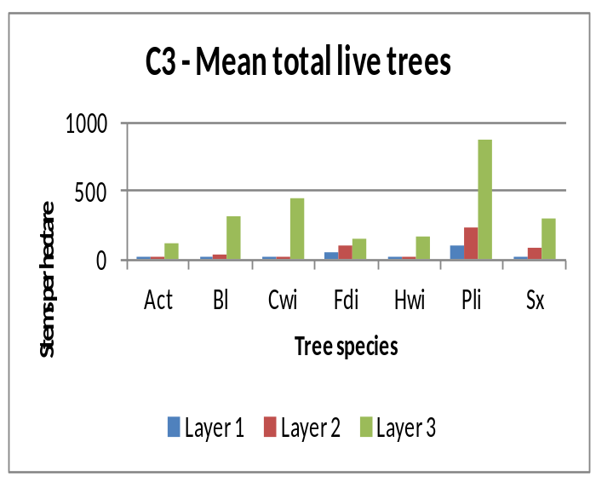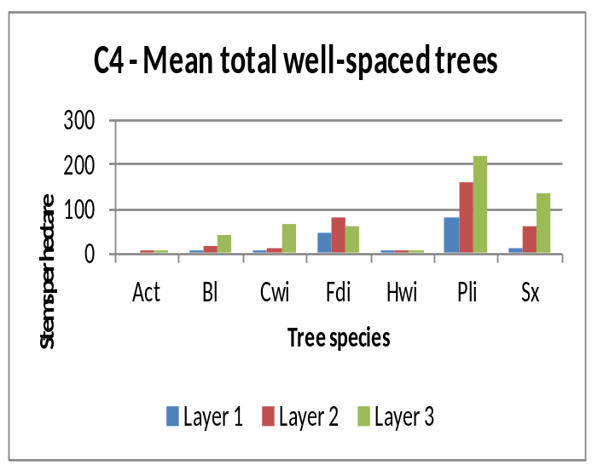

SPECIES COMPOSITION
Inventory labels are condensed representations of several stand attributes that describe conditions at the time of assessment. These attributes include leading, secondary and minor tree species by percentage class (usually rounded to the nearest 10%), average age and height of the dominant and co-dominant trees, a site index estimate, an estimate of crown closure, and the total trees per hectare. Inventory labels provide inputs used by the TASS stand model and by timber supply analysts projecting future stand development for timber supply purposes.
D1 - change in leading species between declaration and SDM
At DEC
ESSFwc ICHmk1 ICHmw1 ICHvk1 ICHwk1 MSdk
SDM Cwi Fdi Lw Pli Sx Cwi Fdi Lw Pli Sx Cwi Fdi Lw Pli Sx Cwi Fdi Lw Pli Sx Cwi Fdi Lw Pli Sx Cwi Fdi Lw Pli Sx
Cwi 0 - - - - 0 - - - - 0 - - - - 1 - - - - 1 - - - - 0 - - - -
Fdi - 0 - - - - 1 - - - - 0 - 1 - - 0 - - - - 1 - - - - 0 - - -
Lw - - 0 - - - - 0 - - - - 3 - - - - 0 - - - - 0 - - - - 0 - - -
Pli - - - 0 - - - - 0 - - - 1 3 - - - - 0 - - - - 0 - - - - 7 -
Se - - - - 1 - - - - 1 - - - - - - - - - - - - - - - - - - - -
Sx - - - - 0 - - - - 0 - - - - 0 - - - - 0 - - - - 0 - 1 - - 1
All - - - - 1 - 1 - - 1 - - 4 4 - 1 - - - - 1 1 - - - - 1 - 7 1

ALL at DEC
SDM Cwi Fdi Lw Pli Sx
Cwi 2 - - - -
Fdi - 2 - 1 -
Lw - - 3 - -
Pli - - 1 10 -
Se - - - - 2
Sx - 1 - - 1
All 2 3 4 11 3
(Shaded values indicate those polygons where the leading species has NOT changed)
(In this TSA, no change in leading species was found in 18 (78%) of the 23 polygons sampled.)

D2 – tree species and layer used to calculate mean basal area
 | Number of Trees |  |  |  |  |  | Mean Polygon BA (m²/ha)
Tree spp. | Layer 1 |  | Layer 2 |  | All | Tree spp. | Layer 1 |  | Layer 2 |  | All
 | Live | Dead | Live | Dead |  |  | Live | Dead | Live | Dead
Bl | 24 |  | 81 | 1 | 106 | Bl | 0.22 |  | 0.23 |  | 0.45
Cwi | 31 | 1 | 69 | 2 | 103 | Cwi | 0.23 | 0.01 | 0.21 | 0.01 | 0.46
Fdi | 111 | 3 | 264 | 7 | 385 | Fdi | 0.83 | 0.02 | 0.80 | 0.02 | 1.67
Pli | 267 | 33 | 633 | 25 | 958 | Pli | 1.92 | 0.28 | 1.89 | 0.08 | 4.18
Sx | 39 |  | 186 | 2 | 227 | Sx | 0.30 |  | 0.57 | 0.01 | 0.87
Minor spp. | 48 | 3 | 135 | 12 | 198 | Minor spp. | 0.36 | 0.03 | 0.38 | 0.03 | 0.80
Total | 520 | 40 | 1368 | 49 | 2049 | Total | 3.86 | 0.34 | 4.08 | 0.14 | 8.44
% by layer | 25.4 | 2.0 | 66.8 | 2.4 |  | % by layer | 45.7 | 4.0 | 48.3 | 1.7
(Minor spp. include: Act, At, Ep, Hwi and Pw)

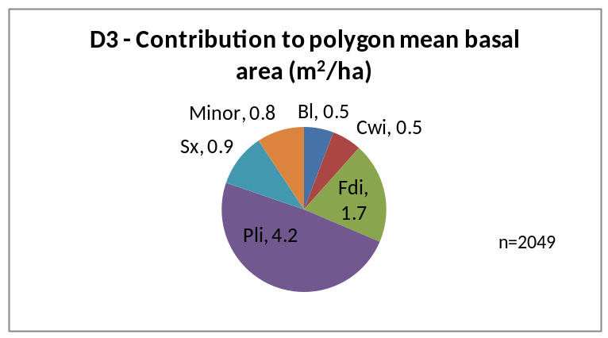

SITE INDEX
Site index was estimated using the growth intercept method. The estimates are the mean values of all available trees for that species in a BEC. Many stands do not have site index estimates recorded prior to the SDM survey.
E1 - mean site index estimate for dominant conifer species
 | Bl |  | Cwi |  | Fdi |  | Pli |  | Sx |  | All
BEC | N | Mean | N | Mean | N | Mean | N | Mean | N | Mean | N
ESFdc3 | - | - | - | - | - |  | - | - | 10 | 21.0 | 10
ESSFwc2 | 2 | 22.5 | - | - | - |  | - | - | 47 | 20.2 | 49
ESSFxc | - | - | - | - | - |  | 9 | 15.2 | 8 | - | 9
ICHmw2 | - | - | - | - | 8 | 25.5 | - | - | - | - | 8
ICHmw3 | - | - | 12 | 21.2 | 37 | 27.6 | 26 | 22.6 | 7 | 23.5 | 82
ICHwk1 | - | - | - | - | - | - | 10 | 21.5 | 10 | 23.5 | 20
IDFwk1 | - | - | - | - | - | - | 19 | 17.1 | - | - | 19
IDFmw2 | - | - | - | - | 40 | 24.3 | 18 | 23.2 | - | - | 58
MSdm2 | - | - | - | - | - | - | 16 | 19.3 | - | - | 16
MSxk | - | - | - | - | - | - | 52 | 18.2 | 1 | 19.2 | 53
MSxk2 | - | - | - | - | - | - | 2 | 17.6 | - | - | 2

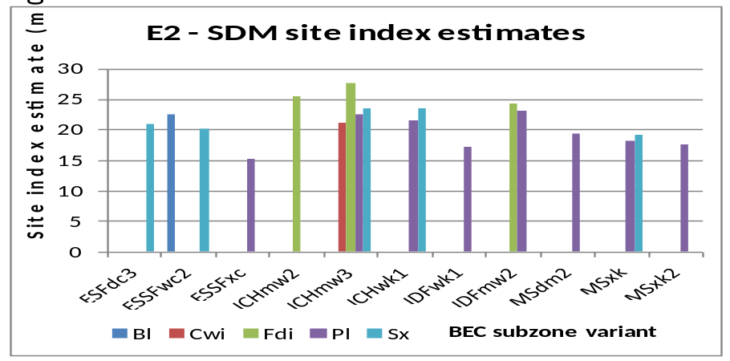
APPENDIX 1
BEC codes - http://www.for.gov.bc.ca/hre/becweb/index.html
Conifer pest codes - http://www.for.gov.bc.ca/hfp/health/fhdata/FS747%20conifer%2020111003.pdf
Conifer Tree Species codes http://www.for.gov.bc.ca/his/results/webhelp/index.htm
Deciduous pest codes - http://www.for.gov.bc.ca/hfp/health/fhdata/FS747%20deciduous%2020111003.pdf
SDM damage criteria - http://www.for.gov.bc.ca/hfp/silviculture/Surveys/SDM_Damage_Criteria_Feb_12_2010(2).pdf
SDM field cards - http://www.for.gov.bc.ca/ftp/HFP/external/!publish/FREP/indicators/FS%201357-SDMCard%20March%2012%2009.pdf
SDM survey protocol http://www.for.gov.bc.ca/ftp/HFP/external/!publish/FREP/Indicators/SDM%20Protocol%202011.pdf
Stocking Standards tables - http://www.for.gov.bc.ca/hfp/silviculture/stocking_stds.htm

APPENDIX 2
The complete list of openings, and polygons used in this report are listed here

TSA=Kamloops Survey Year=2010 District=DHW
MAPSHEET | POLYGON | Year Logged (Smry) | BEC (Smry) | Polygon Net Area (Popn) | Leading Spp @ SDM (Smry) | Stand Age (Calc) | Total Live Trees @ SDM (Smry) | WS @ SDM (Smry) | SI @ SDM (Smry)
82M 062 6039 | A | 1989 | IDFmw2 | . | Pli | 21 | 3120 | 1040 | 24.0

TSA=Kamloops Survey Year=2010 District=DKA
MAPSHEET | POLYGON | Year Logged (Smry) | BEC (Smry) | Polygon Net Area (Popn) | Leading Spp @ SDM (Smry) | Stand Age (Calc) | Total Live Trees @ SDM (Smry) | WS @ SDM (Smry) | SI @ SDM (Smry)
82M 012 001 | SU_1 | . | IDFmw2 | . |  | . | . | . | .
82M 013 050 | 1 | . | ICHmw3 | . |  | . | . | . | .
82M 022 017 | 1 | . | ICHmw3 | . |  | . | . | . | .
82M 022 050 | 1 | . | ESSFwc2 | . |  | . | . | . | .
92I 057 058 | 1309 | . | MSxk | . |  | . | . | . | .
92I 066 036 | 1 | . | IDFdk1 | . |  | . | . | . | .
92I 097 012 | 923 | . | MSxk | . |  | . | . | . | .
92I 098 059 | A | . | ESSFdc3 | . |  | . | . | . | .
92P 004 001 | 1 | . | IDFdk1 | . |  | . | . | . | .
92P 028 017 | 2 | . | MSxk | . |  | . | . | . | .
92P 030 046 | SU1 | . | IDFmw2 | . |  | . | . | . | .

TSA=Kamloops Survey Year=2011 District=DHW
MAPSHEET | POLYGON | Year Logged (Smry) | BEC (Smry) | Polygon Net Area (Popn) | Leading Spp @ SDM (Smry) | Stand Age (Calc) | Total Live Trees @ SDM (Smry) | WS @ SDM (Smry) | SI @ SDM (Smry)
82M 023 8449 | 99 | 1979 | ICHmw3 | 6.8 | Cwi | 32 | 9840 | 980 | 20.9
82M 023 8452 | 9998 | 1983 | ICHmw3 | 5.6 | Fdi | 28 | 3340 | 1120 | 29.1
82M 024 8202 | 9999 | 1986 | ICHmw3 | 8.4 | Cwi | 25 | 1820 | 520 | 21.8
82M 024 8215 | 563 | 1989 | ICHmw3 | 6.7 | Fdi | 22 | 8400 | 1280 | 22.4
82M 033 1216 | A | . | ICHmw3 | 31.0 | Fdi | . | 4280 | 920 | 26.9
82M 033 8250 | 482A1 | . | ICHmw3 | . |  | . | . | . | .
82M 061 1082 | 841 | . | IDFmw2 | 11.0 | Pli | . | 2520 | 640 | 22.4
82M 063 6011 | 14 | . | ICHmw3 | 16.0 | Pli | . | 2620 | 820 | 23.2
82M 073 6059 | B | 1988 | ICHwk1 | 17.1 | Pli | 23 | 1340 | 1040 | 22.0
82M 073 6074 | A | 1992 | ICHmw3 | 9.6 | Pli | 19 | 4020 | 940 | 22.3
82M 082 1090 | A | 1995 | ESSFwc2 | 18.0 | Sx | 16 | 1000 | 780 | 21.1
82M 095 6075 | 1 | . | ICHwk1 | 35.0 | Sx | . | 3800 | 1080 | 23.1
83D 003 6047 | A | . | ESSFwc2w | 44.4 | Sx | . | 1160 | 680 | 16.4
83D 004 7036 | 635 | . | ESSFwc2 | 9.2 | Sx | . | 1640 | 1160 | 20.1
83D 035 5048 | B | . | ESSFwc2 | 24.2 | Sx | . | 1080 | 500 | 19.1
92P 060 5012 | C | 1990 | IDFmw2 | 43.8 | Fdi | 21 | 1960 | 900 | 21.0
92P 060 5012 | D | 1990 | IDFmw2 | 18.9 | Fdi | 21 | 4360 | 1100 | 21.7

TSA=Kamloops Survey Year=2011 District=DKA
MAPSHEET | POLYGON | Year Logged (Smry) | BEC (Smry) | Polygon Net Area (Popn) | Leading Spp @ SDM (Smry) | Stand Age (Calc) | Total Live Trees @ SDM (Smry) | WS @ SDM (Smry) | SI @ SDM (Smry)
82M 001 051 | 1A | . | MSdm2 | 15.4 |  | . | . | . | .
82M 003 209 | A | . | ESSFwc2 | 18.9 |  | . | . | . | .
82M 022 085 | SU 1 | . | ICHmw2 | . |  | . | . | . | .
92I 066 066 | A1 | . | MSxk | 10.0 |  | . | . | . | .
92I 066 066 | B2 | . | MSxk | 15.8 |  | . | . | . | .
92I 087 031 | A | . | MSxk | 23.1 |  | . | . | . | .
92I 097 003 | 927 | . | MSxk | 20.0 |  | . | . | . | .
92I 097 056 | A | . | MSdm2 | 27.7 |  | . | . | . | .
92I 097 057 | A | . | MSxk2 | 33.5 |  | . | . | . | .
92P 008 050 | 983 | . | ESSFxc | 38.1 |  | . | . | . | .
92P 029 024 | 828 | . | MSxk | 13.5 |  | . | . | . | .
92P 029 097 | E | . | MSdm2 | 5.6 |  | . | . | . | .

TSA=Kamloops Survey Year=2012 District=DHW
MAPSHEET | POLYGON | Year Logged (Smry) | BEC (Smry) | Polygon Net Area (Popn) | Leading Spp @ SDM (Smry) | Stand Age (Calc) | Total Live Trees @ SDM (Smry) | WS @ SDM (Smry) | SI @ SDM (Smry)
82M 044 8036 | 167AFCA1869357 | . | ESSFwc2 | . |  | . | . | . | .
82M 074 6058 | A | . | ICHwk1 | 11.0 |  | . | . | . | .
82M 082 1078 | 651 | . | ICHmw3 | 34.8 |  | . | . | . | .

TSA=Kamloops Survey Year=2012 District=DKA
MAPSHEET | POLYGON | Year Logged (Smry) | BEC (Smry) | Polygon Net Area (Popn) | Leading Spp @ SDM (Smry) | Stand Age (Calc) | Total Live Trees @ SDM (Smry) | WS @ SDM (Smry) | SI @ SDM (Smry)
82M 002 012 | 821 | . | IDFmw2 | 7.0 |  | . | . | . | .
82M 011 014 | 5313A18693STA | . | ICHmk1 | 34.7 |  | . | . | . | .
82M 021 040 | 820 | . | IDFmw2 | 9.0 |  | . | . | . | .
82M 031 116 | A | . | ICHmk1 | 8.1 |  | . | . | . | .
92I 100 059 | A18686-598-1-FCA | . | MSdm2 | 59.2 |  | . | . | . | .
92P 008 029 | 974 | . | ESSFxc | 13.0 |  | . | . | . | .

